Add Activity Master

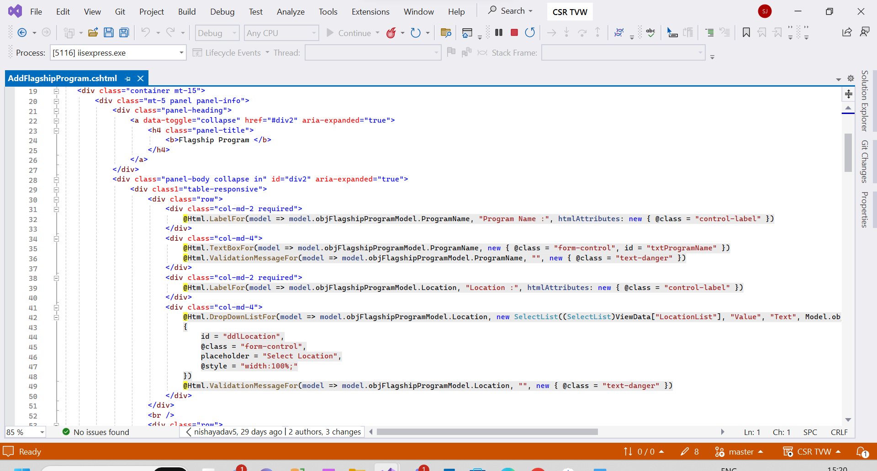

View Activity Master

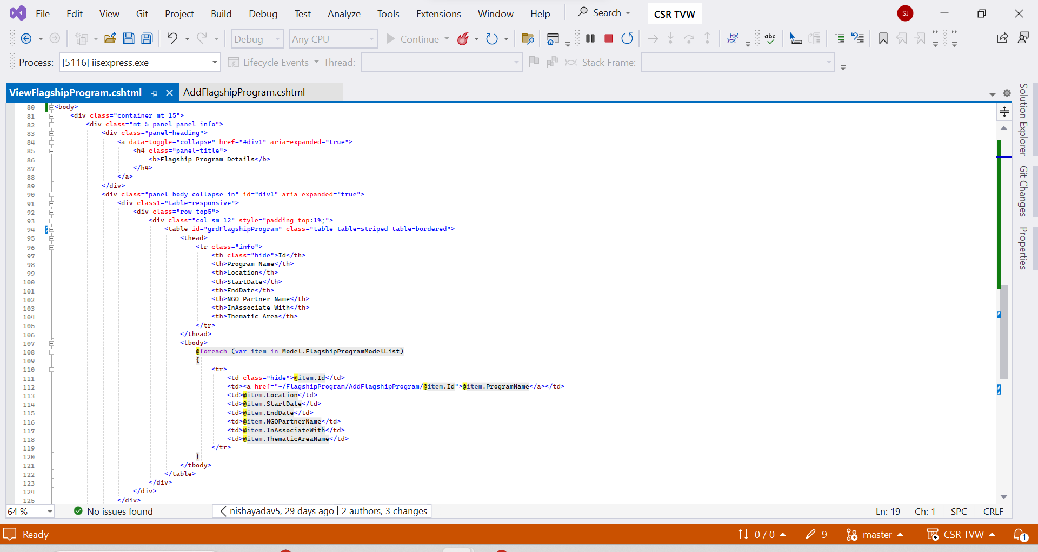

Add Participant Details

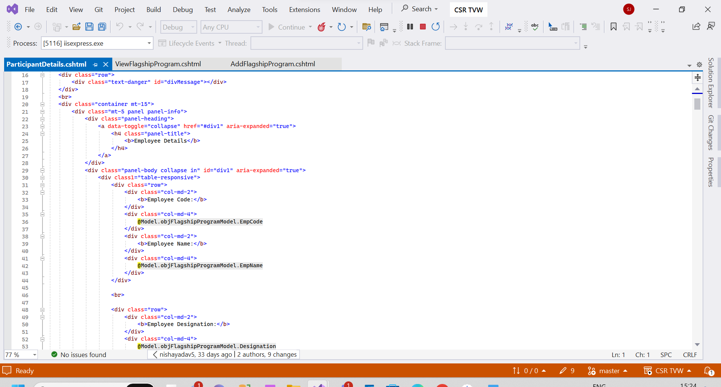

View Participant Details

